**Davyd Safonov**

S00255881

1. Sample of the Json data

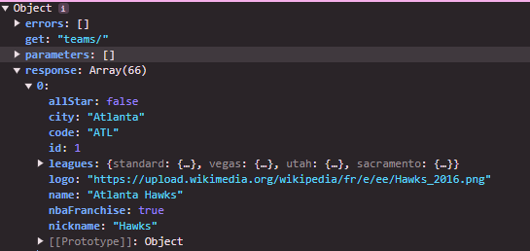

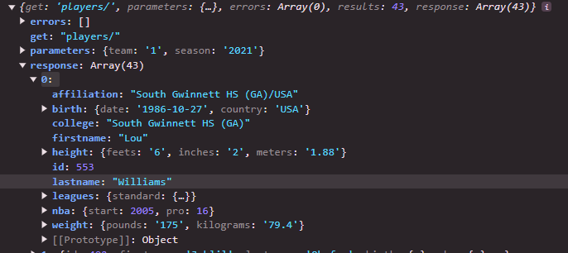

1. response array:

name

logo

city

conference

division

response array:

firstname

lastname

birthdate

country

1. Diagram

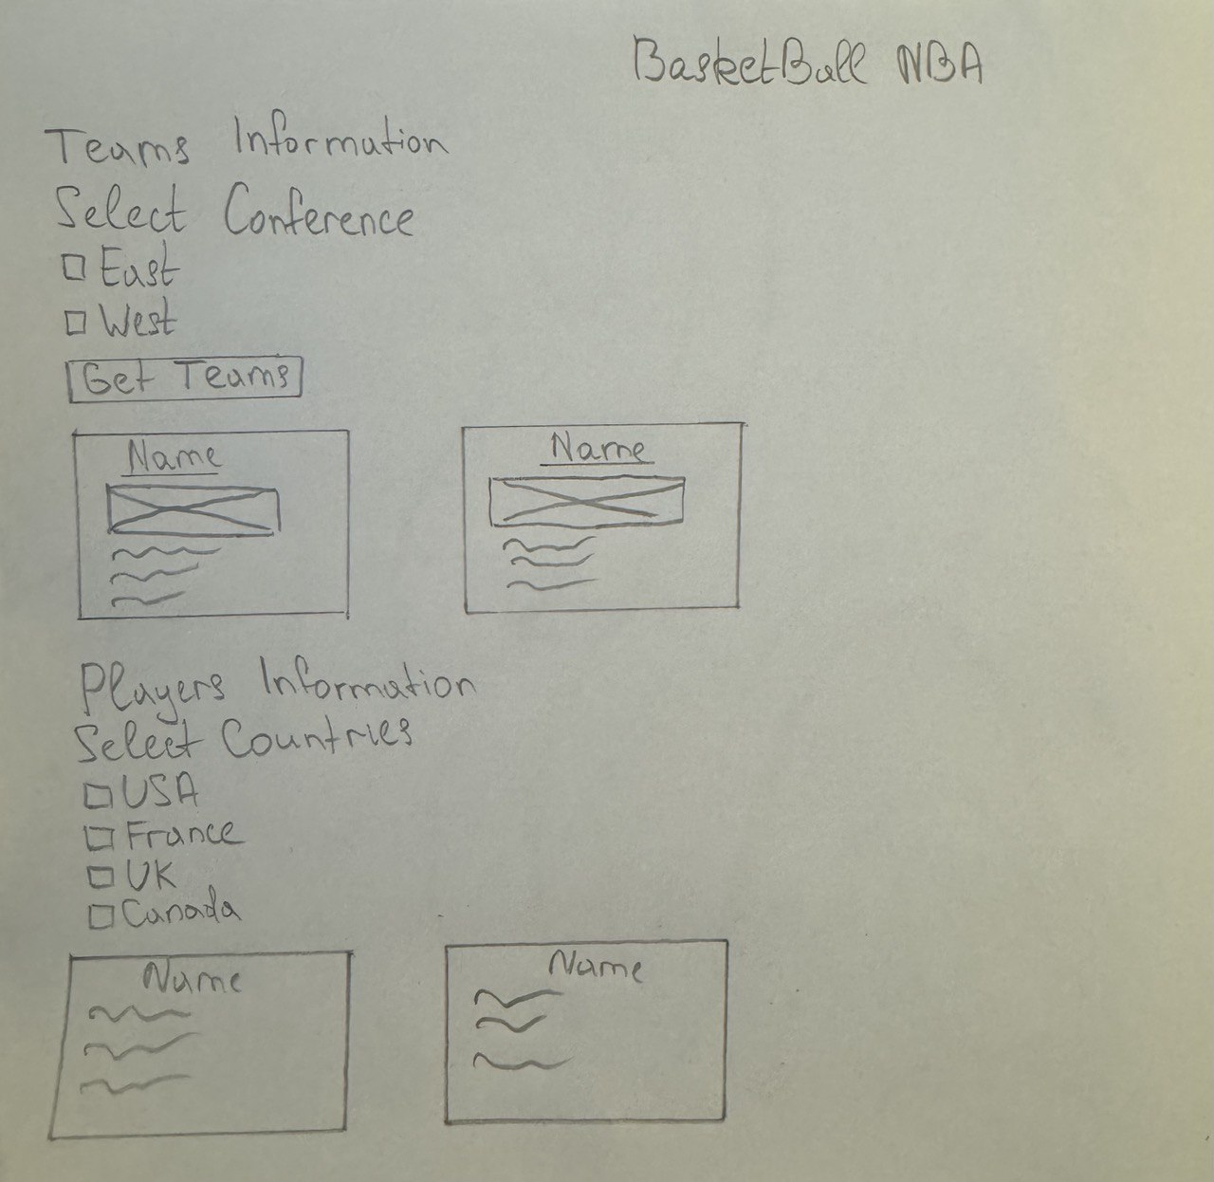

1. Link to GitHub

https://github.com/Davyd30/ClientSideScripting-Assignment-DavydSafonov